CAREERHUB

A Project Report Submitted

in Partial Fulfillment of the Requirement

for the Degree in Master of Computer Applications

Undertaken at

**National Institute of Electronics and Information Technology (NIELIT)**

**, Shillong, Government of India.**

By

Banteilang Nongsiej,

University Roll No. 22STAMCA002



Department of Computer Science

St. Anthony’s College

Shillong

July, 2024

**Certificate from Organization in their given format OR Letter Head of the Organization OR Logo of Organization (if any) Name of Organization Address of Organization Contact of Organization**

Shri Santhosh V T

State Informatics Officer

NIC Meghalaya State Centre, Shillong Meghalaya

Email: vt[dot]santhosh[at]nic[dot]in

**CERTIFICATE**

This is to certify that ***Mr. Banteilang Nongsiej****,* a 4th Semester MCA student of St. Anthony’s College, Shillong, has successfully completed his project work entitled **“*NERIE Learning*”**, at ***NIC, Meghalaya State Centre***, National Informatics Centre, Ministry of Electronics & Information Technology, Shillong-793001.

His work has been prepared as partia­­l fulfillment of the requirement for the degree of MCA, to be awarded by North Eastern Hill University. The project work submitted here is the bona-fide work of the student.

During his stay at “NIC Meghalaya State Centre”, he has displayed a very sincere and consensus attitude towards work.

I wish him success in all future endeavors.

*Signature*

**Shri Santhosh V T**

State Informatics Officer

Scientist-F

**Certificate from Organization in their given format OR Letter Head of the Organization OR Logo of Organization (if any) Name of Organization Address of Organization Contact of Organization**

**CERTIFICATE**

This is to certify that ***Mr. Banteilang Nongsiej,*** a 4th Semester student of MCA from ***St. Anthony’s College****,* ***Shillong*** has completed his full- semester project work entitled “***CAREERHUB***” at National of Electronics and Information Technology (NIELIT), Shillong, Government of India, from **February, 2024** to **July, 2024,** under my guidance and supervision for the partial fulfillment of the requirement for the award of the degree of Master of Computer Application under ***North Eastern Hill University***.

During his stay in the National of Electronics and Information Technology (NIELIT), Shillong, Government of India, he has displayed very sincere and consensus attitude toward his work. His performance during work was found to be satisfactory.

I wish him success in all his future endeavors.

*Signature*

**Project Guide**

Shri. Gordon Kynsai Nongkynrih

Scientist-C



**Department of Computer Science**

**St. Anthony’s College, Shillong**

**Affiliated to North Eastern Hill University, Shillong**

**CERTIFICATE**

This is to certify that the project report entitled “***CAREERHUB***” is an approved work done by ***Mr. Banteilang Nongsiej*** (Roll No- 22STAMCA002) in the partial fulfillment of the requirement for the award of the degree of Master of Computer Application under North Eastern Hill University, Shillong from St. Anthony’s College, Shillong.

*Signature*

**Fr. Joby Joseph**

**Vice Principal**

**St. Anthony’s College**

**Shillong—793001**

**Meghalaya**

*Signature*

**Dr. Anjan Das**

**Director, MCA**

**St. Anthony’s College**

**Shillong—793001**

**Meghalaya**



**Department of Computer Science**

**St. Anthony’s College, Shillong**

**Affiliated to North Eastern Hill University, Shillong**

**CERTIFICATE**

This is to certify that the Project work titled ***“CareerHub”*** is thebonafide work done by ***Mr. Banteilang Nongsiej, North Eastern Hill University, 22STAMCA002,*** under my guidance during the fourth semester of the course.

*Signature*

**Internal Guide**

*Dr. Probidita Roychoudhury*

The project seminar was held on **Date** July, 2024 at St. Anthony’s College, Shillong

Date: External Examiner

**ACKNOWLEDGEMENT**

Note of acknowledgement by the student.

Table of Contents

Introduction— About the project 1

Synopsis 2

Organization’s Profile 3

Client’s Profile 4

System Study 5

Existing System 5

Proposed System 5

User Requirements 6

Software Requirements 6

Hardware Requirements 6

Data Flow Diagram 7

Module Diagram 8

Menu Diagram 9

Entity Relationship Diagram 10

Database Design and Data Dictionary 11

Database Schema Design 12

Input/Output Screens 13

Feasibility Study 14

Future Enhancements 15

Conclusion 16

Bibliography 17

Source Code 18

# Introduction— About the project

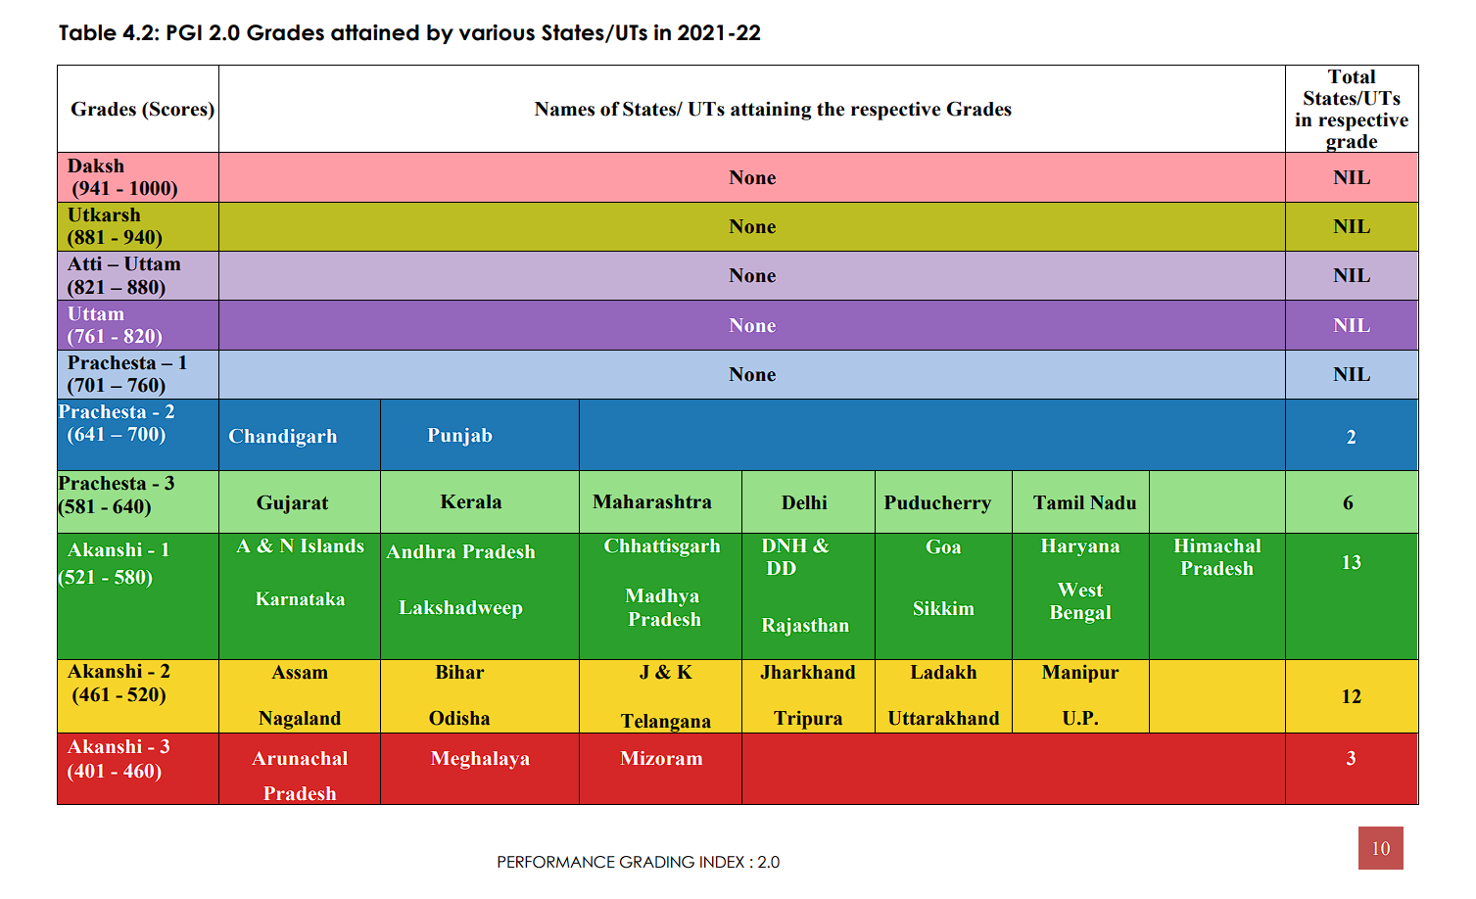

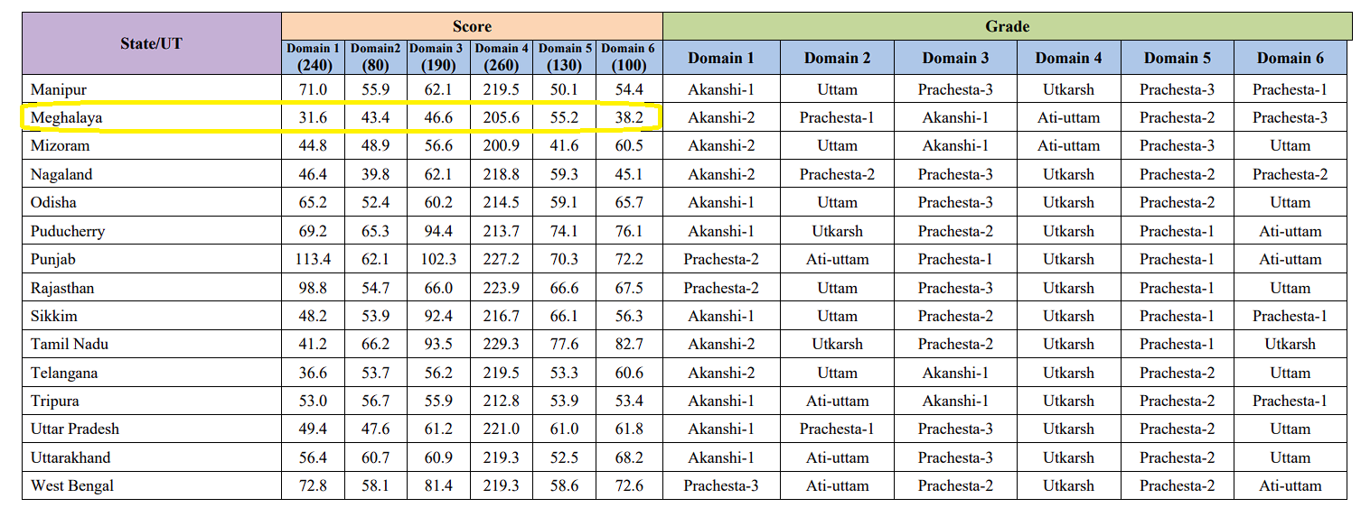

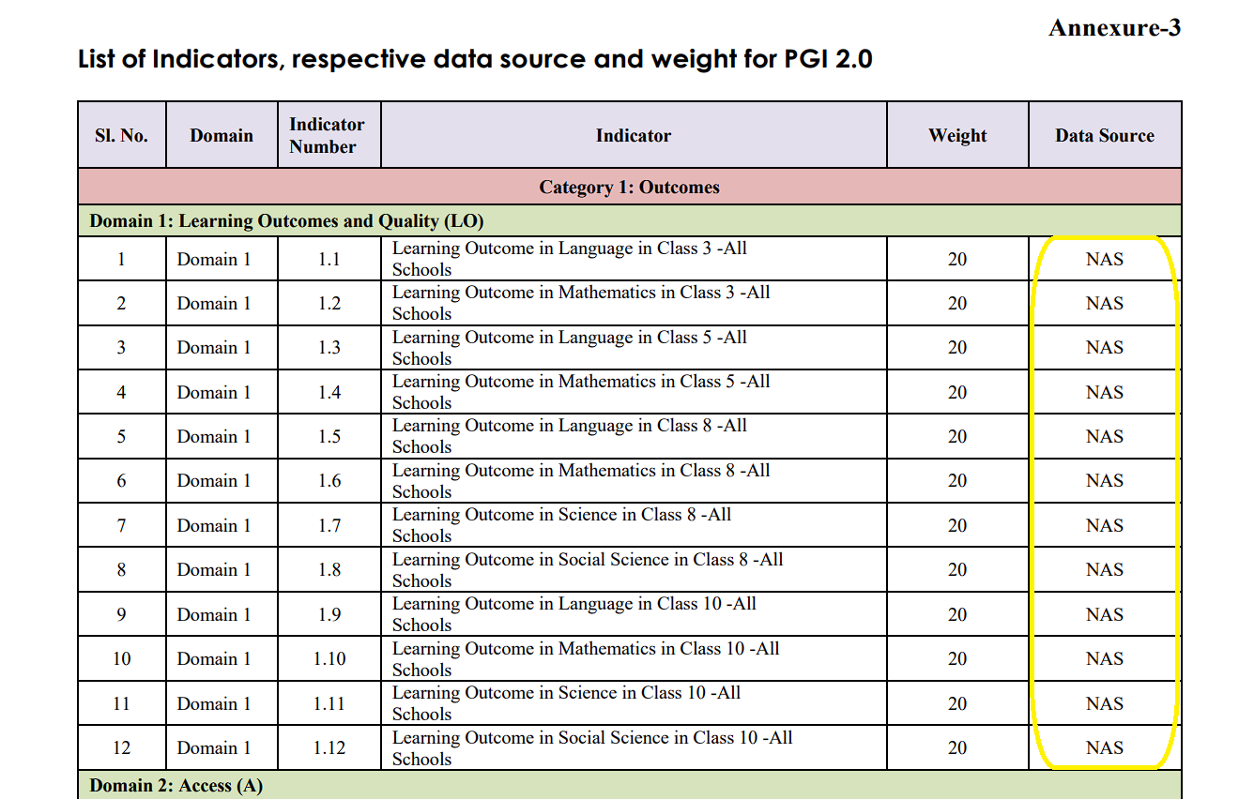

# Synopsis

# Organization’s Profile

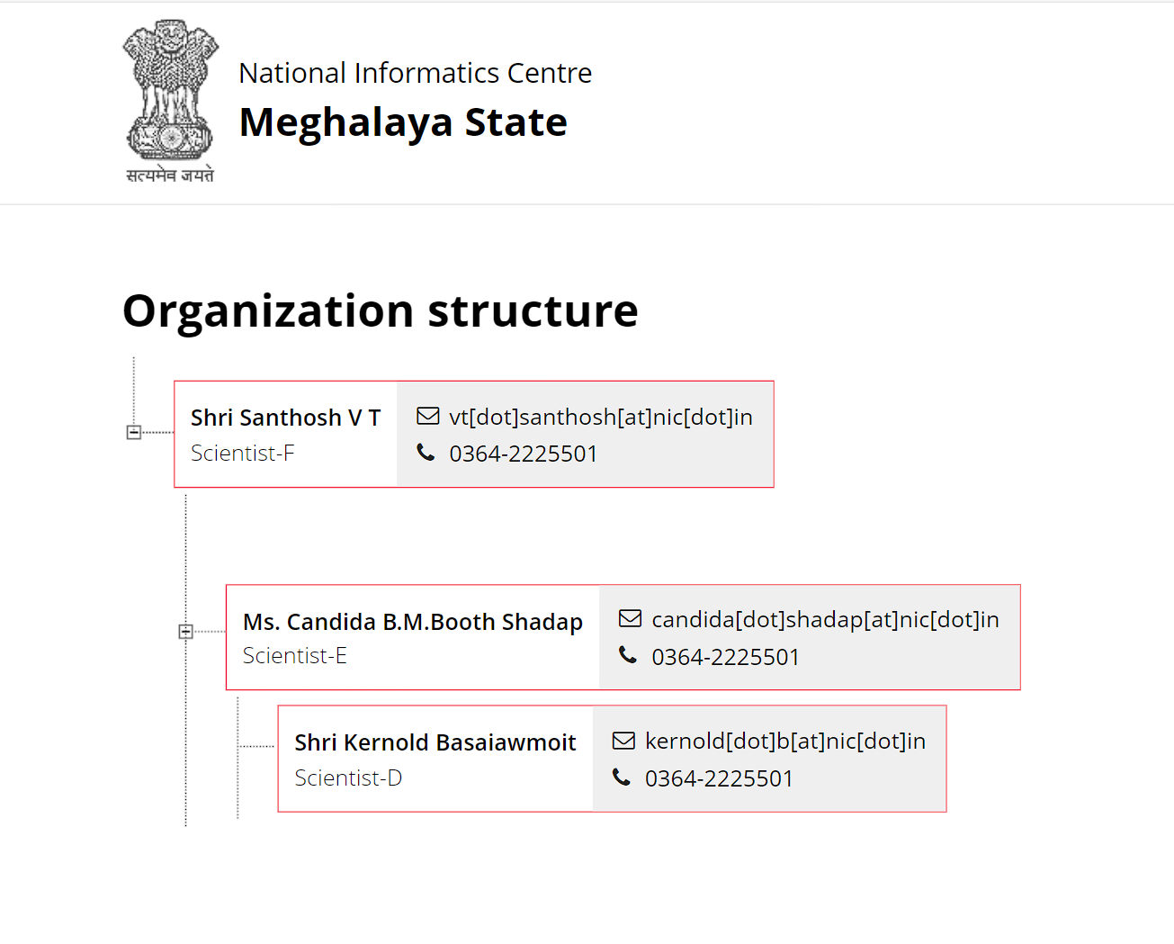

# Client’s Profile

# System Study

## Existing System

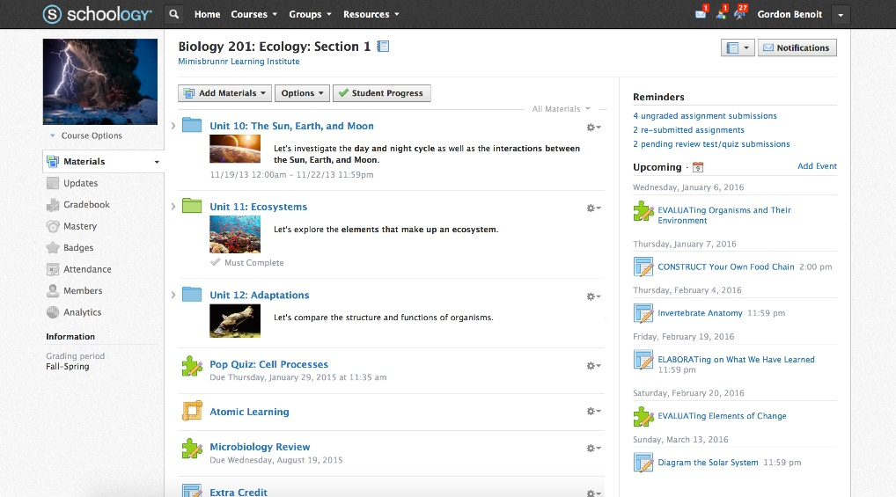

## Proposed System

# User Requirements

## Software Requirements

## Hardware Requirements

# Data Flow Diagram

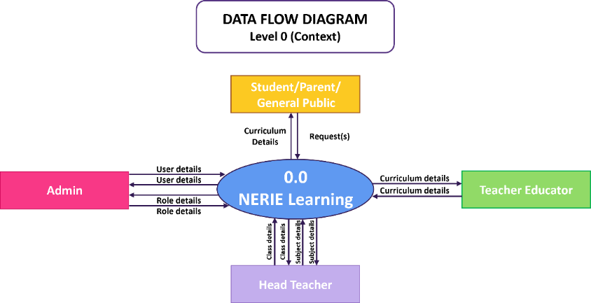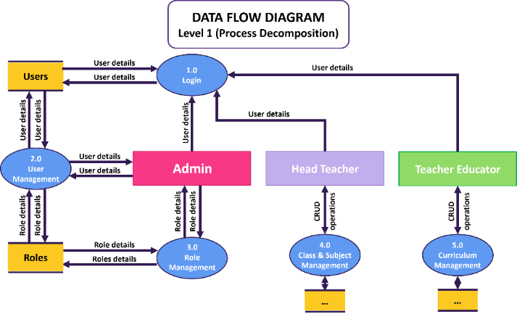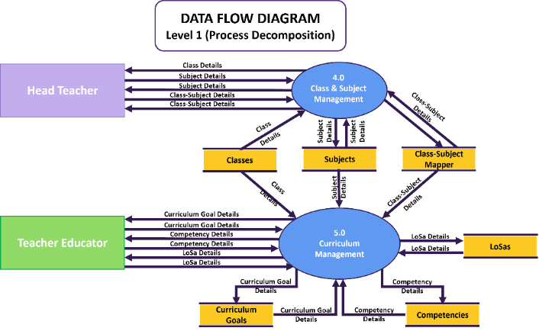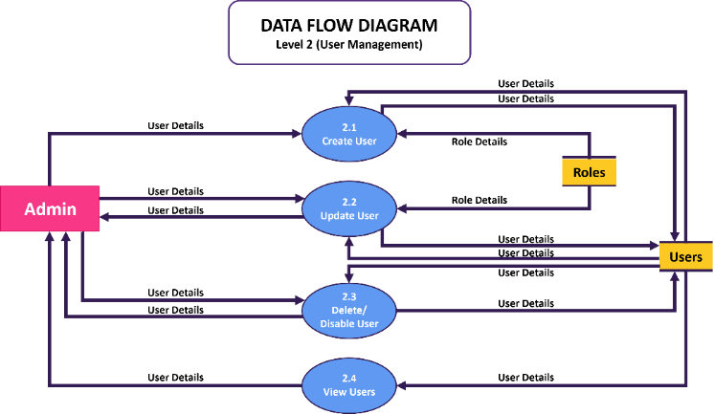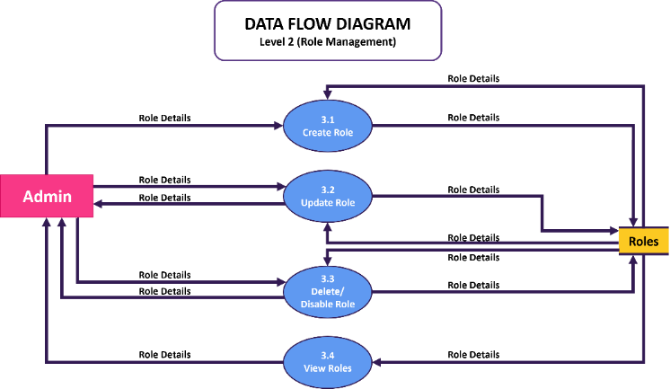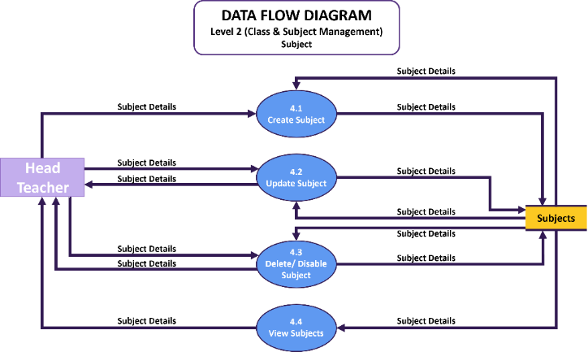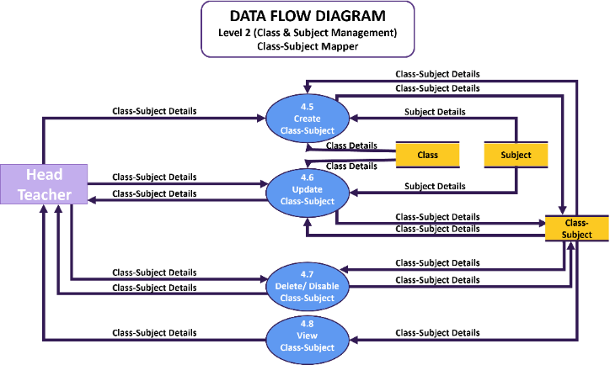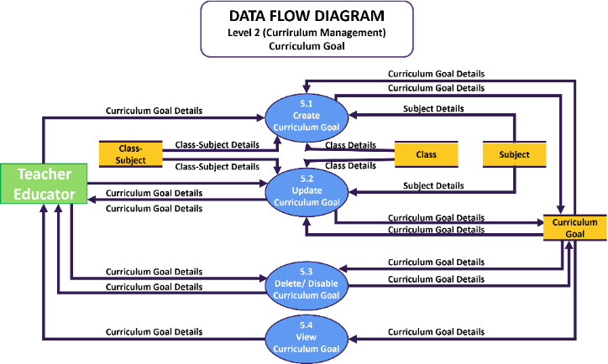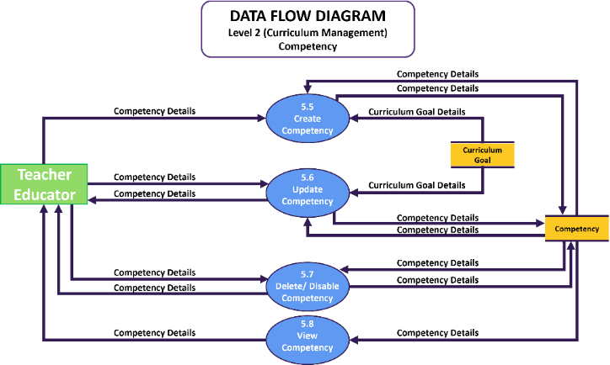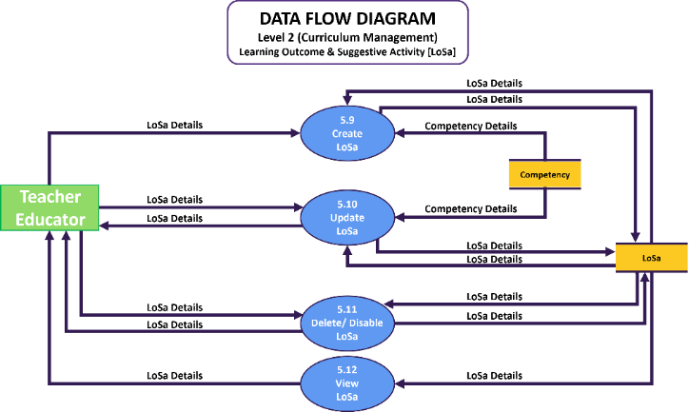

# Module Diagram

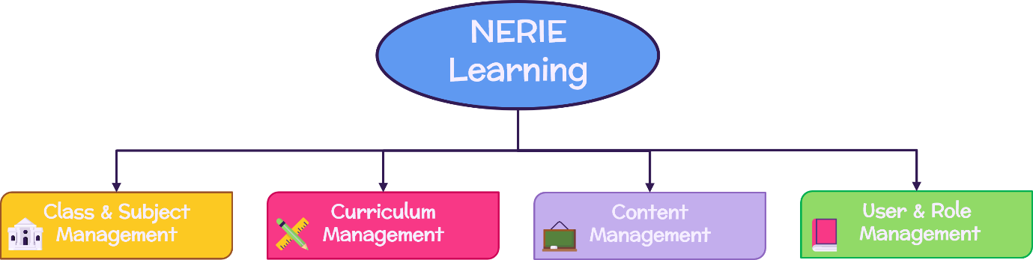

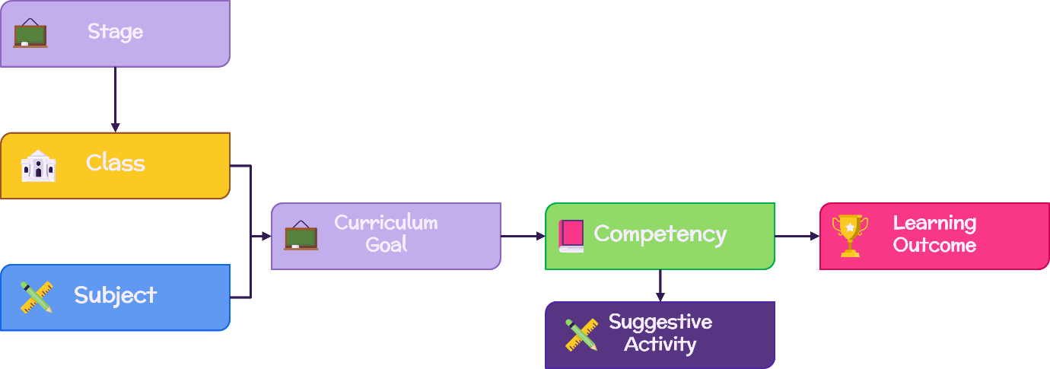

# Menu Diagram

# Entity Relationship Diagram

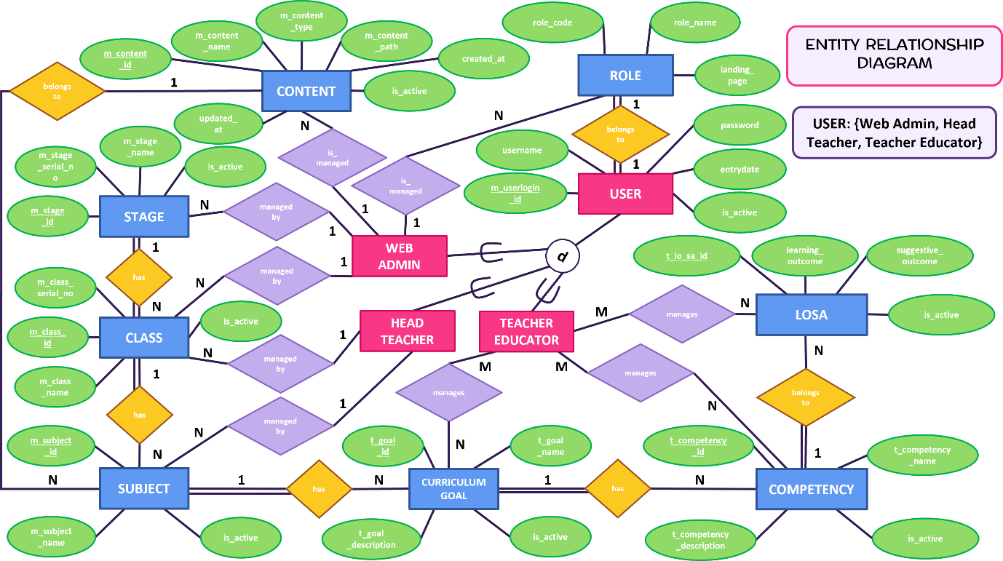

# Database Design and Data Dictionary

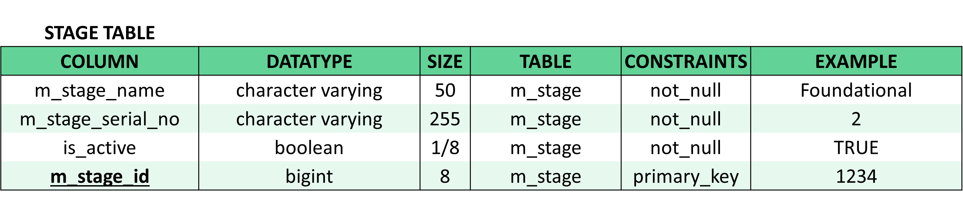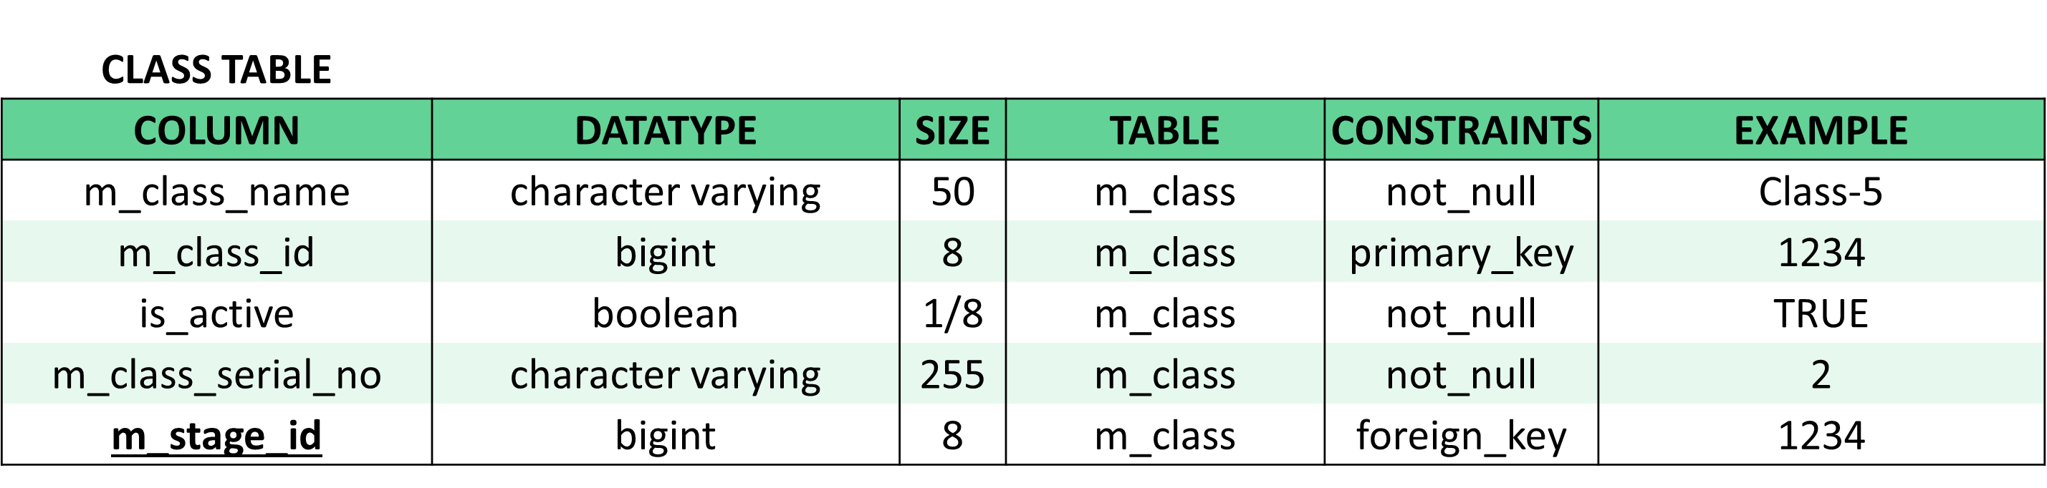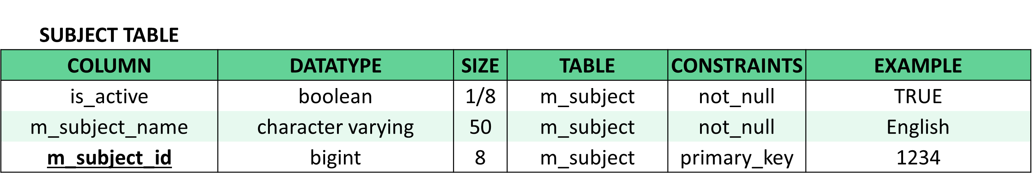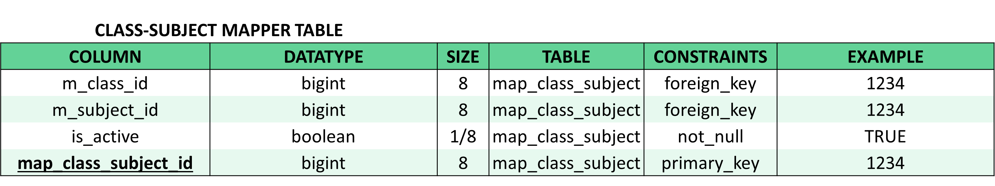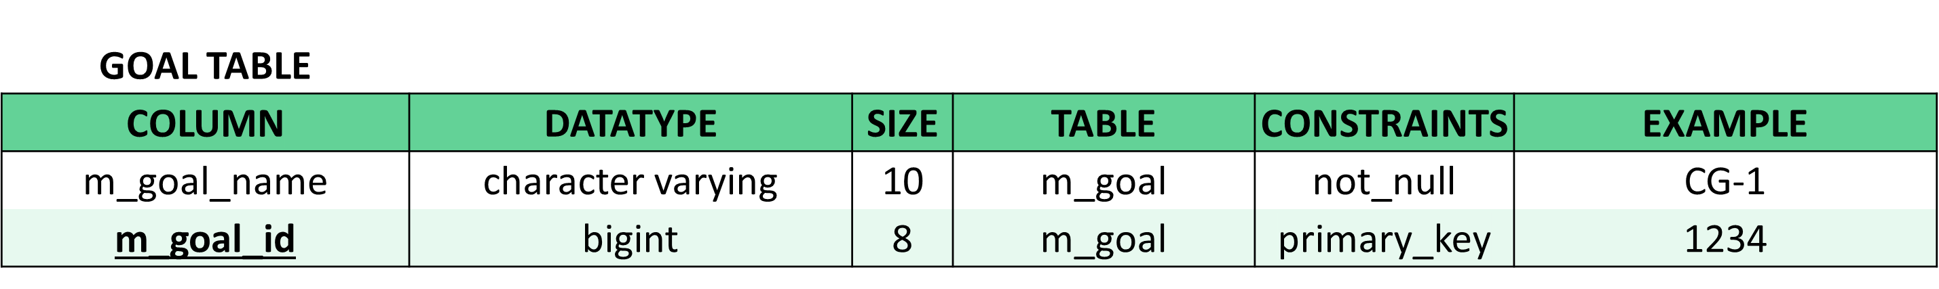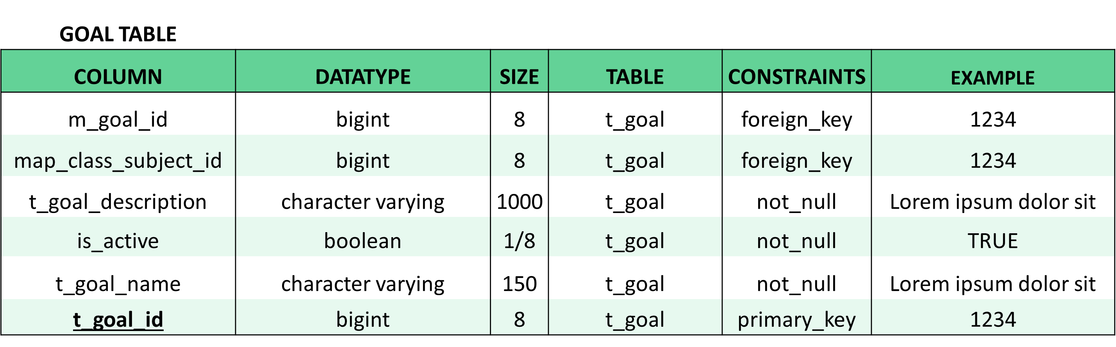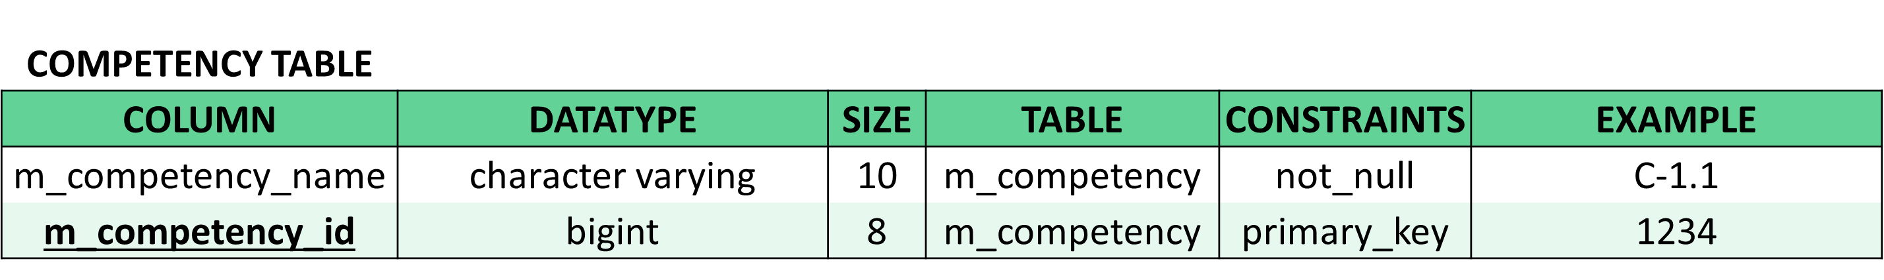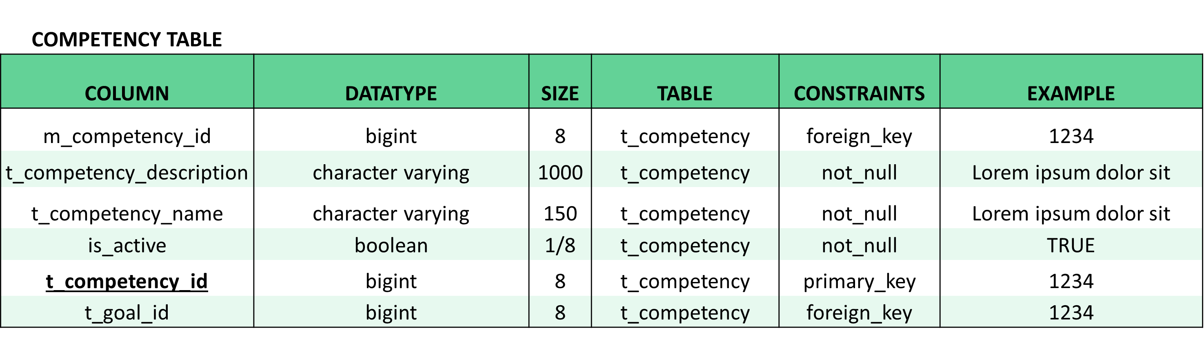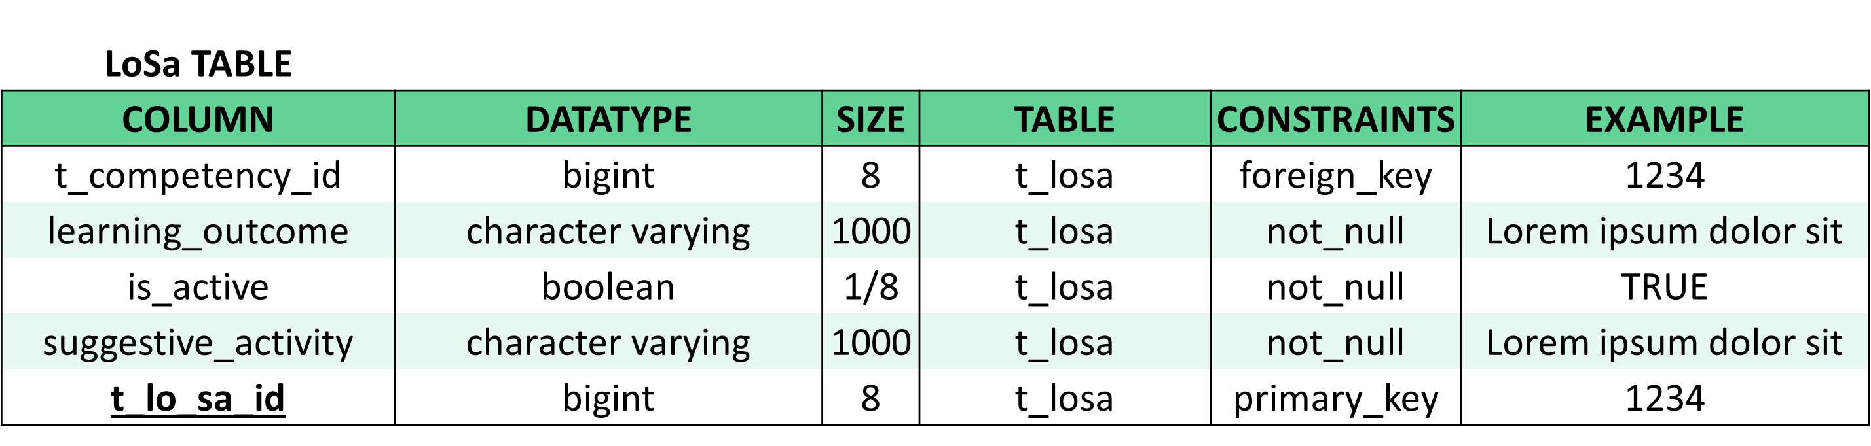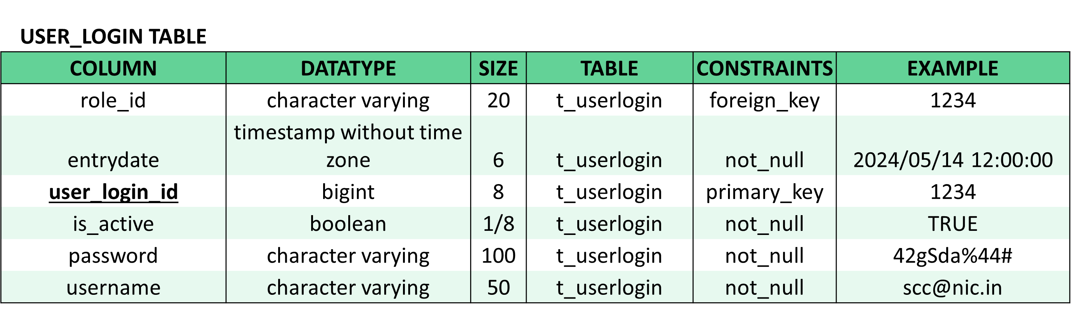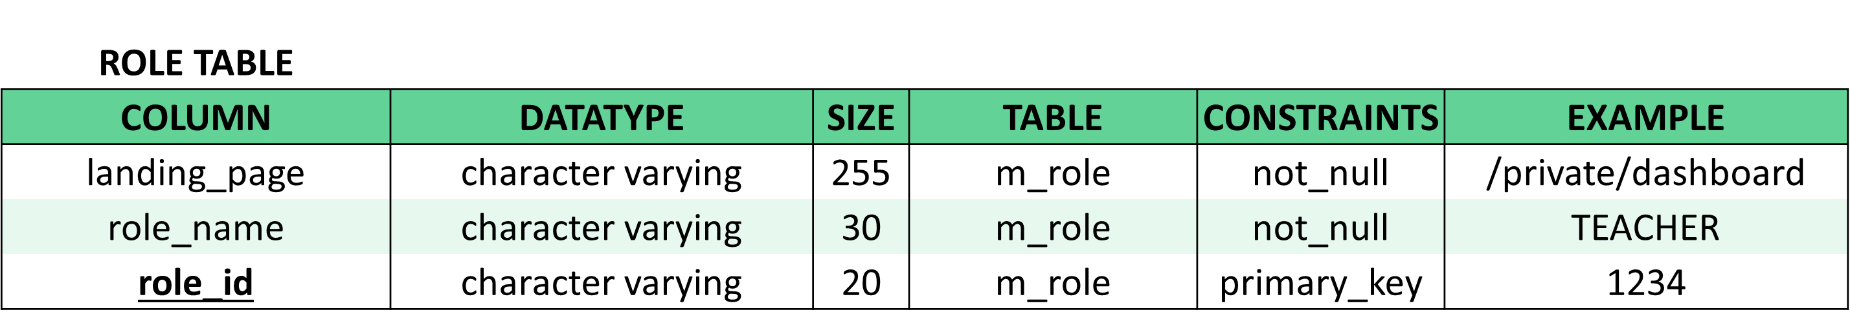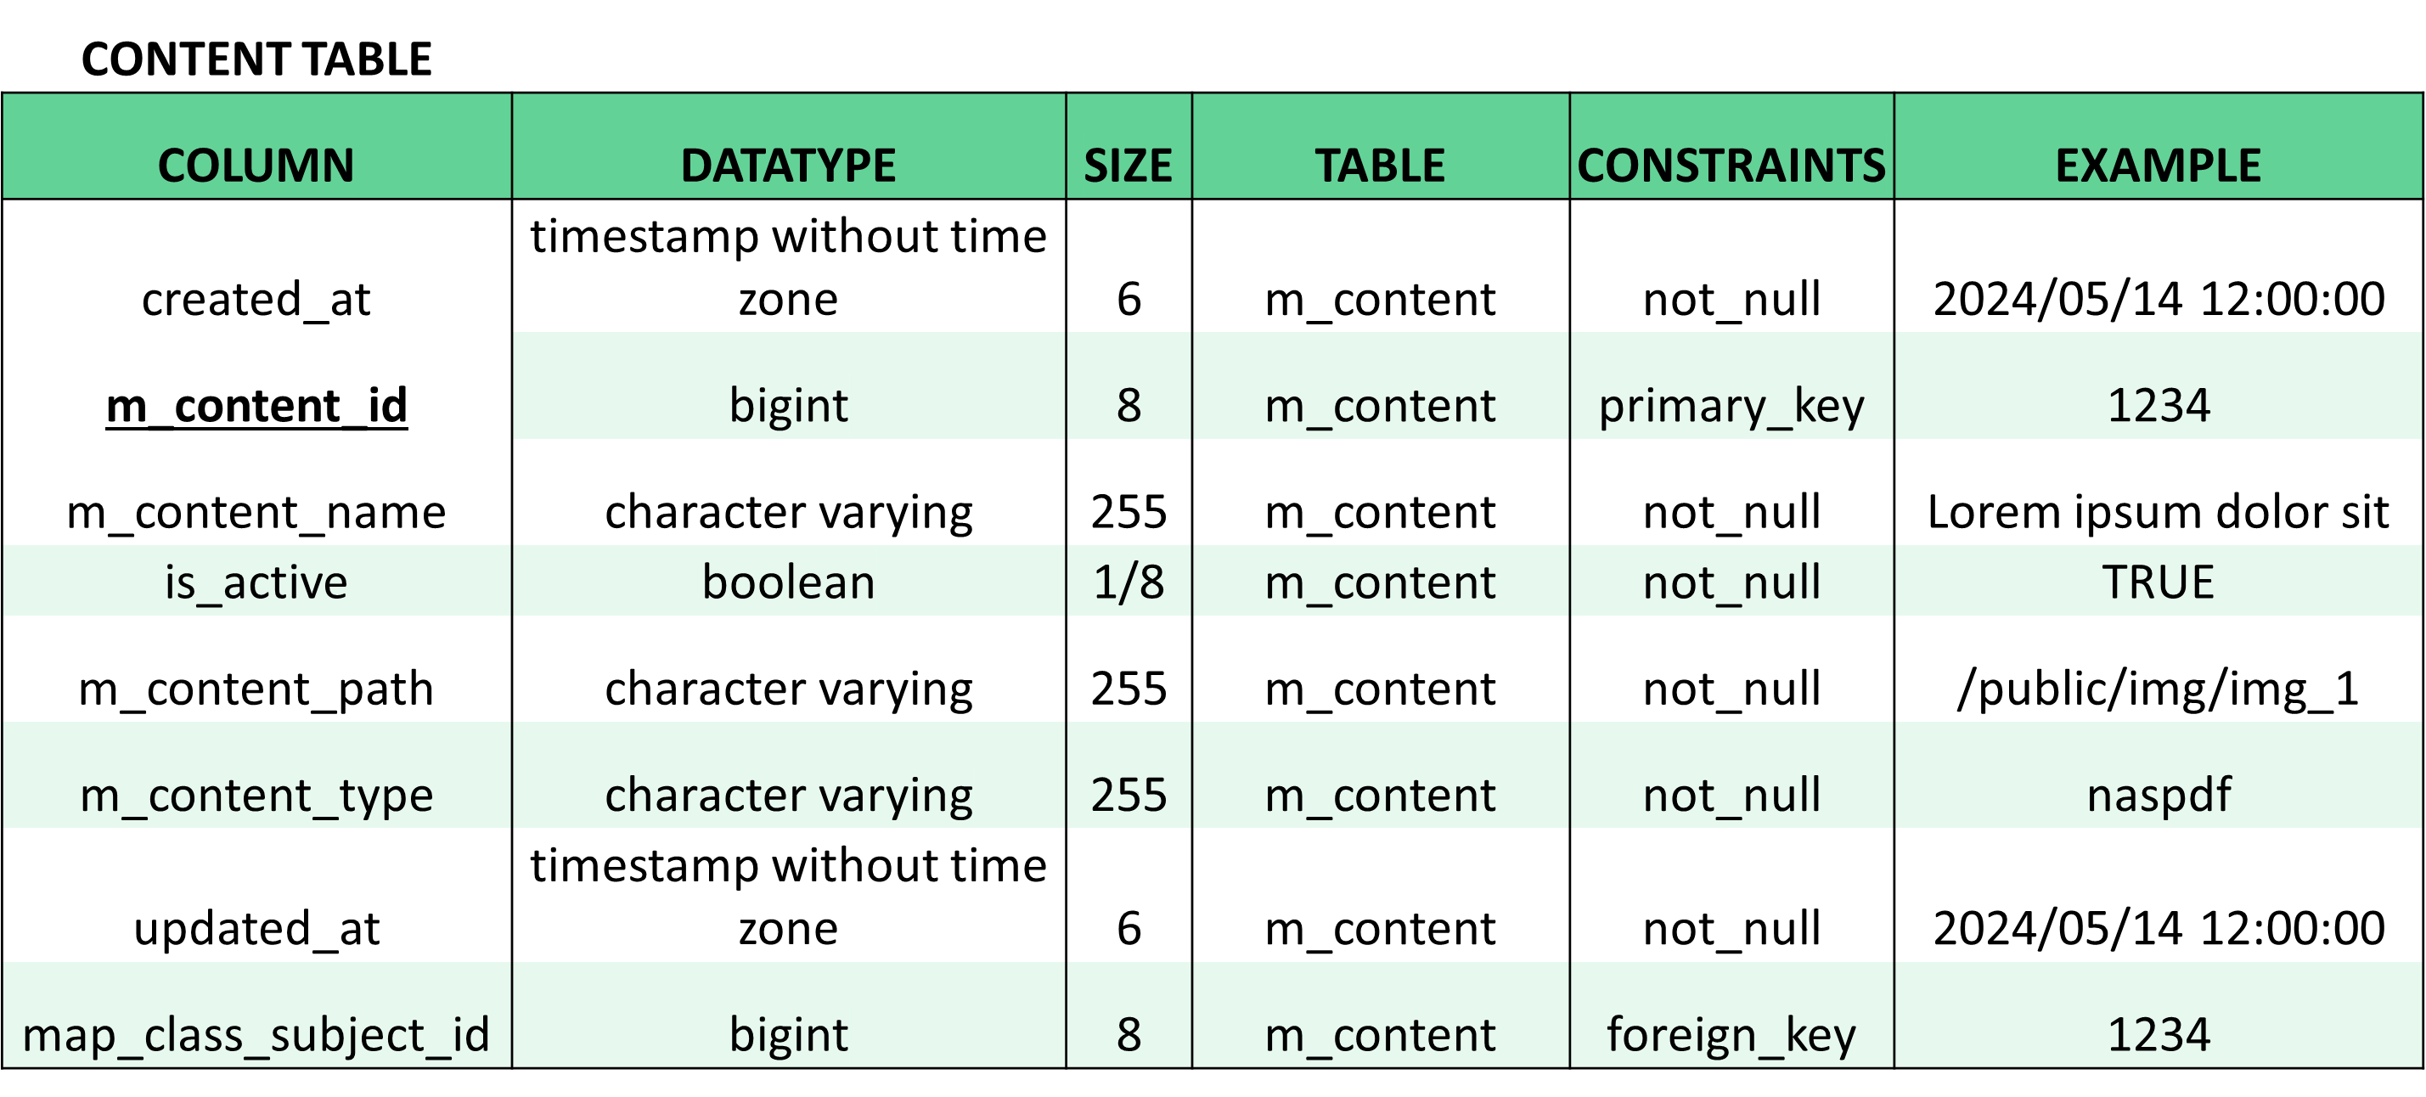

# Database Schema Design

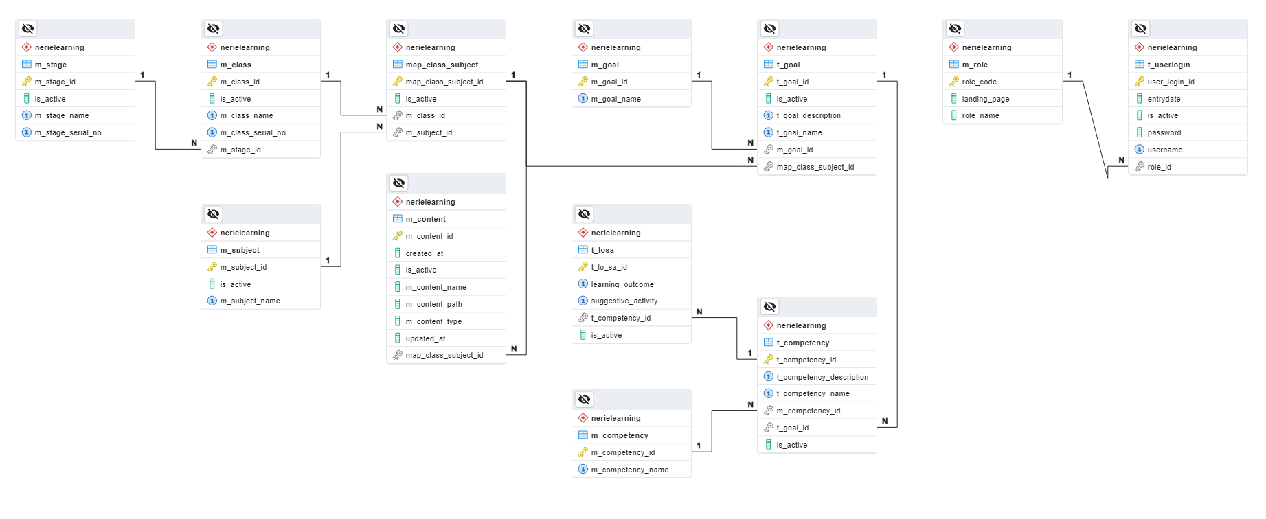

# Input/Output Screens

# Feasibility Study

# Future Enhancements

# Conclusion

# Bibliography

# Source Code